Peizos Used: 6,7,8,9

Event Log:

06:10:59 Arrive on Site

08:00:35 Divers in the water, Setting up locations.

09:45:07 Divers out of the water.

09:53:35 Spike of 1 PSI on Peizos result of water flush.

10:00:24 Active Hole set to 35 - Pump 1

10:00:31 Active Hole set to 47 - Pump 2

10:00:45 Start Grout Pump 1 on hole 35

10:04:35 Spike Detected in Peizo 7. Peak at 0.5 Psi

10:24:22 Bubbles on packer 47, Divers tightening fitting.

10:24:51 Divers in the water.

10:27:08 Peizo7 starts to rise. 0.6 psi over 15 minutes.

10:30:20 Start Grout Pump on hole 47

10:51:50 Stop Grout Pump 1,2

10:53:41 Start Grout Pump 1 on hole 47

11:03:38 Stop Grout Pump 1

11:03:56 Running Slump test and collecting cylinders.

11:06:05 Start Grout Pump 1 on hole 35

11:15:32 Stop Grout Pump 1/2

11:26:42 Start Grout Pump 1 on hole 35

11:35:40 Stop Grout Pump 1

11:36:52 Start Grout Pump 1 on hole 35

12:01:52 Stop Grout Pump 1

12:03:17 Stop Grout Pump 2

12:07:57 Start Grout Pump 1 on hole 35

12:08:53 Start Grout Pump 2 on hole 47

12:09:59 Stop Grout Pump 2

12:10:42 Stop Grout Pump 1

12:13:14 Start Grout Pump 2 on hole 47

12:14:12 Start Grout Pump 1 on hole 35

12:28:02 Stop Grout Pump 1,2

12:42:03 Start Grout Pump on both

12:43:34 Stop Grout Pump 1,2

12:59:52 Divers in the water.

13:08:40 Start Grout Pump on both

13:12:32 Divers out of the water.

13:40:21 Start Grout Pump on both

13:56:12 Stop Grout Pump 2

13:57:14 Divers in the water.

14:24:43 Active Hole set to 36

14:42:10 Start Grout Pump 1 on hole 47

14:59:05 Divers out of the water.

15:00:06 Start Grout Pump 2 on hole 36

15:19:10 Stop Grout Pump 2

15:18:02 Active Hole set to 41

15:32:24 Stop Grout Pump 1,2

15:47:43 Start Grout Pump 1 on hole 41

15:52:48 Stop Grout Pump 1

16:01:58 Start Grout Pump 1 on hole 41

16:11:43 Stop Grout Pump 1

16:22:34 End of Day. All stop.

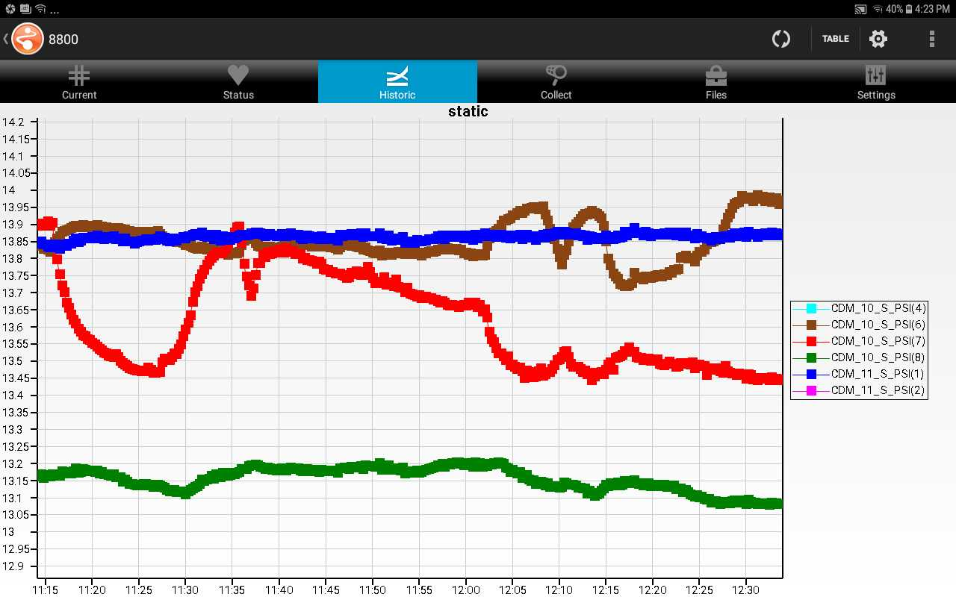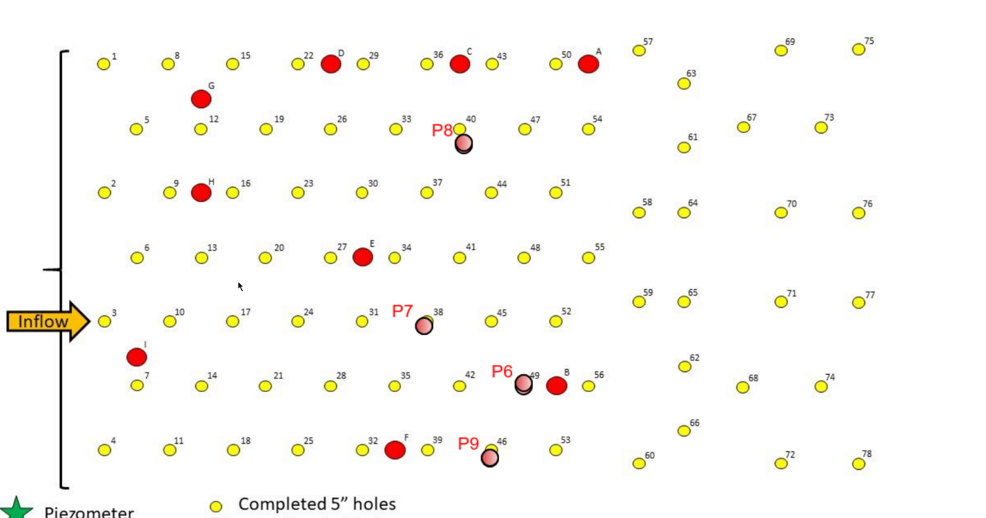

Peizometer Data.

